ExTestAdvDispScaling.vi

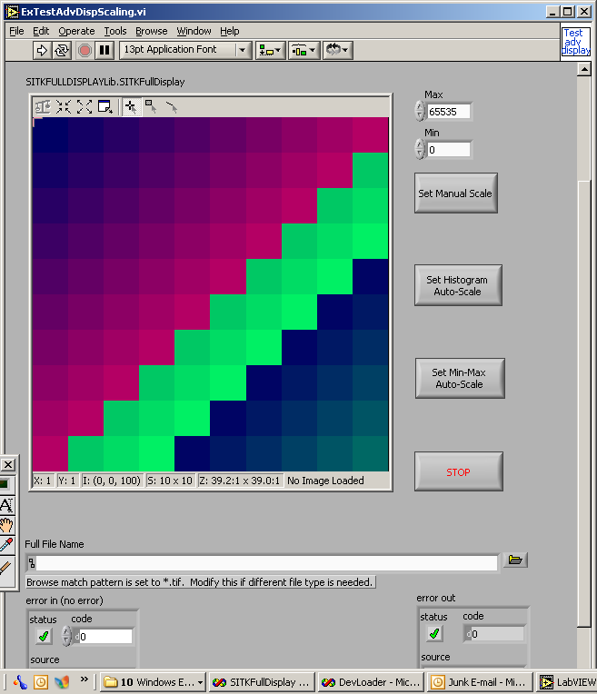
Select Tif file to load:
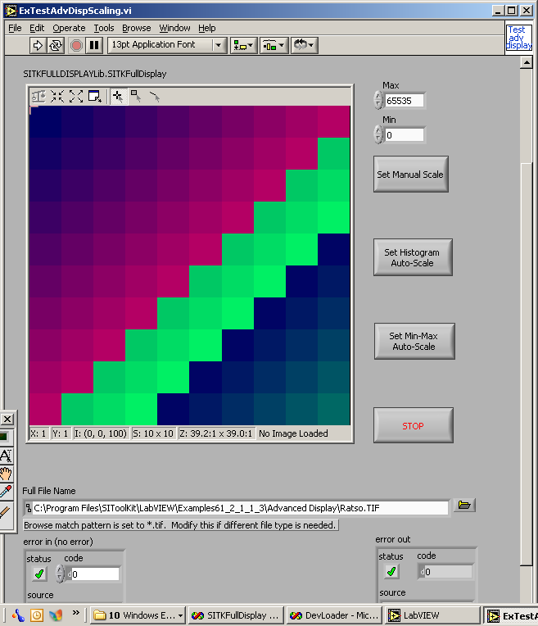

Hit white go arrow on top.
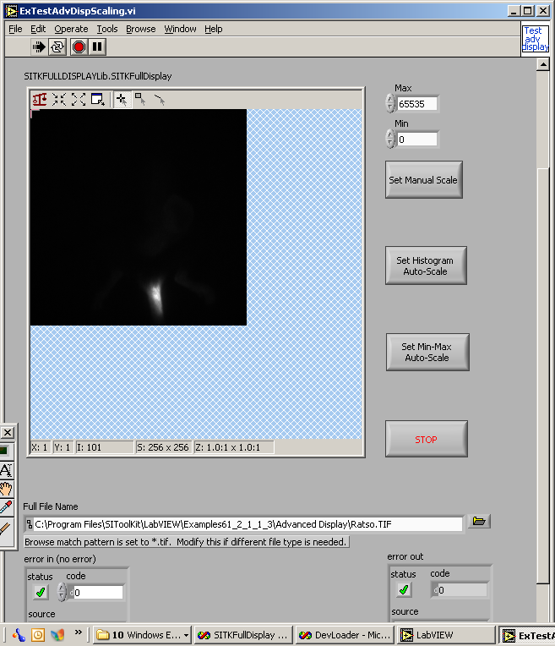

At top of display is a auto scale, zoom in, zoom out, and pin. Select Pin:
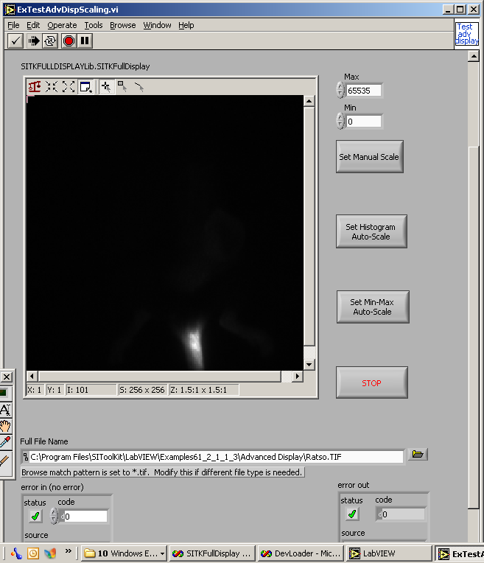

Now select Manual scale button, for Ratso Tif file select 500 for max and 0 for min. This allows user to set the min and max to scale the image to.
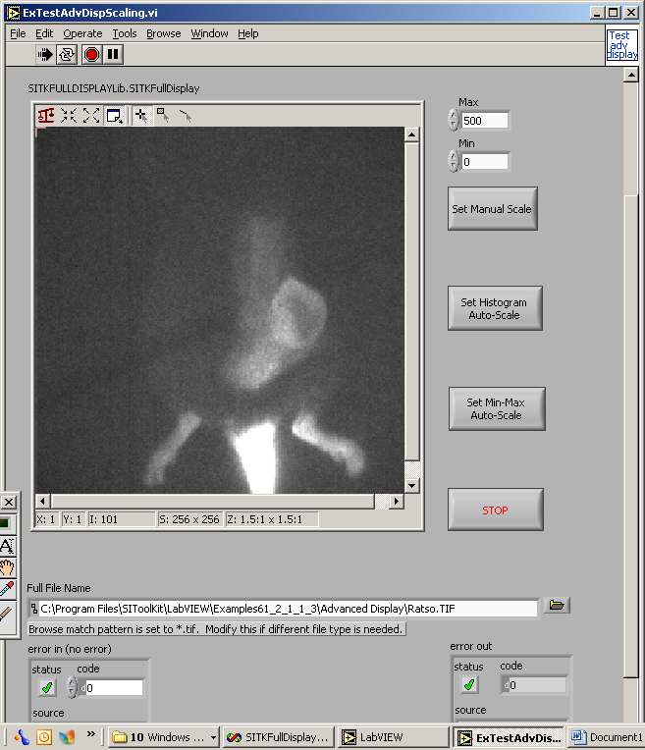

Now select histogram autoscale (this is similar to 5%-95%, and uses a histogram to how to scale the image, ignoring hot pixels and dead pixels).:
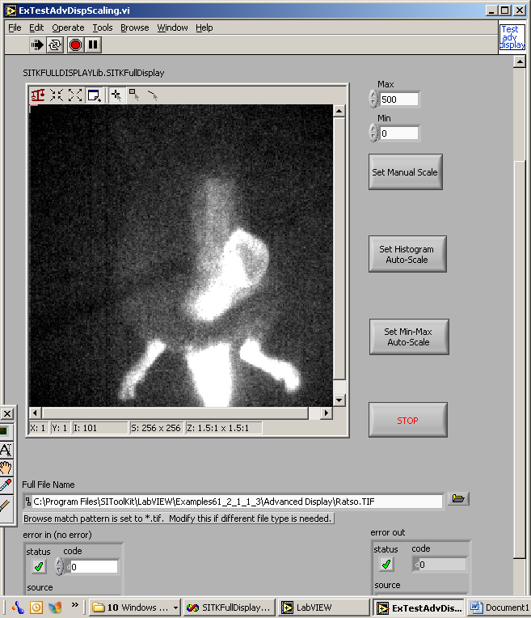
Now hit min-max (which uses the minimum value found in image and the maximum value found in image):
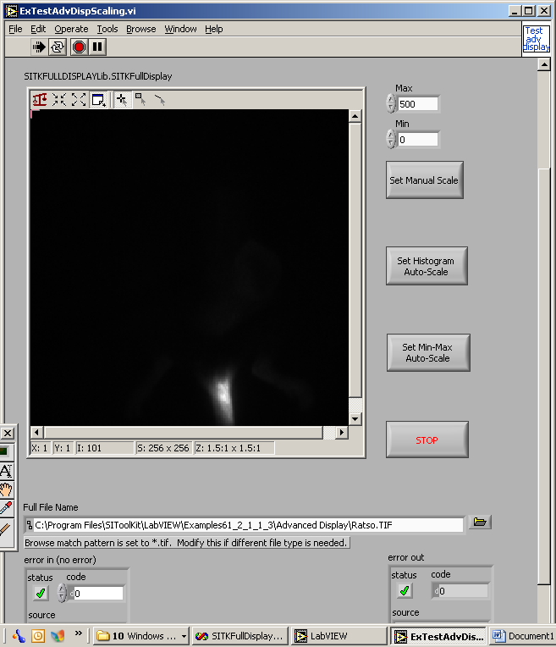

You can also right click in the image to get auto-scaling, pinning and zooming in and out:
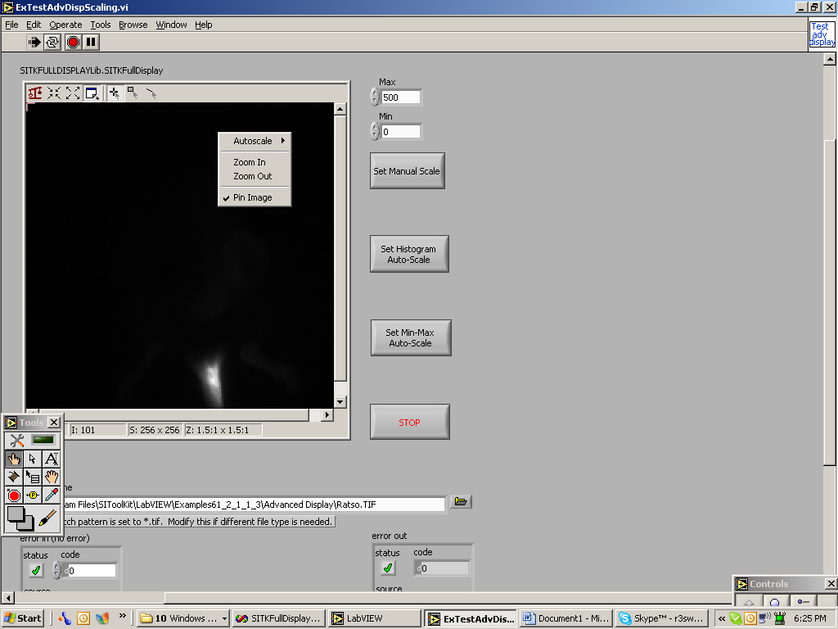

Hit the stop button to end program.

